**WYTHENSHAWE A.F.C.**

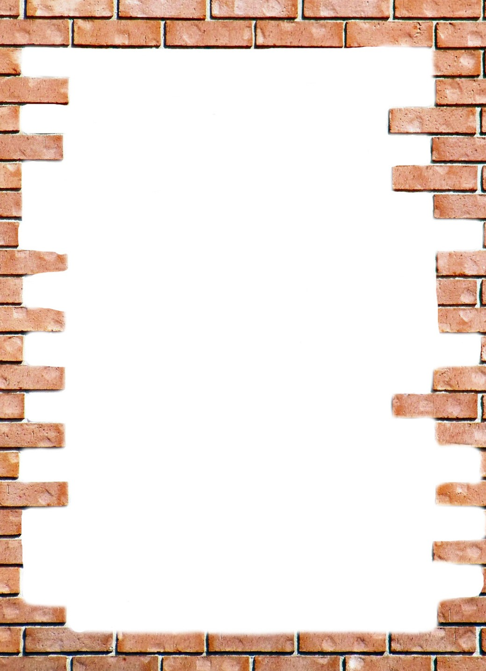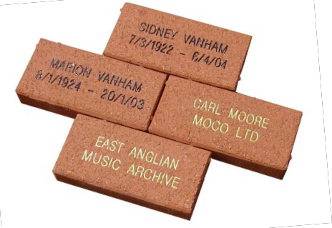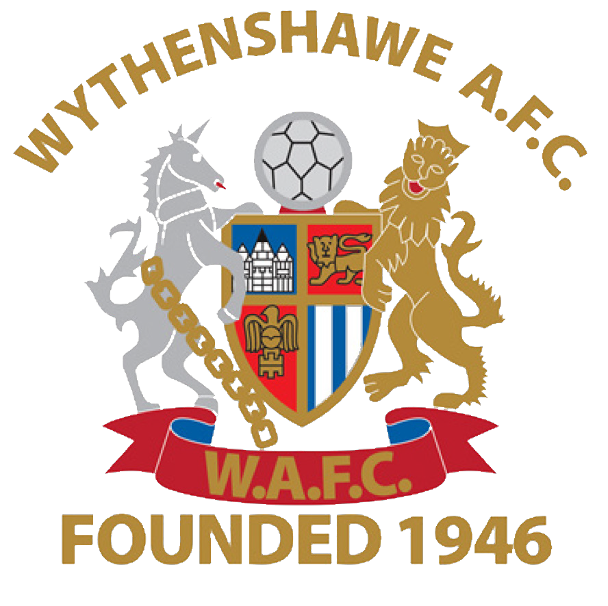

**BUY A BRICK**

and join the Wall of Fame

for Single Brick £50.00 inc VAT

or Double Brick £200.00 inc VAT

Our new clubhouse will be completed for the start of

the 2017-2018 season. This is going to be a fantastic facility

for all our members.

Now you have the chance to join the Wythenshawe A.F.C. Wall of Fame and help the club meet the costs of the fixtures and fittings including a bar, fully equipped kitchen, furniture and an AV System.

Please fill out the details overleaf and return the form by email with payment by BACS transfer Royal Bank of Scotland Acct 19204018 Sort 83-04-25 to

[sales@wythenshaweafc.com](mailto:sales@wythenshaweafc.com) or post to FAO Basil Kabbani, Wythenshawe A.F.C., Hollyhedge Park, 105 Altrincham Road, Sharston, Wythenshawe, Greater Manchester M22 4US.

If you have any questions please contact Basil at [sales@wythenshaweafc.com](mailto:sales@wythenshaweafc.com) or on 07771 996 498.

Example of sample brick

WYTHENSHAWE A.F.C.

Hollyhedge Park

105 Altrincham Road Sharston Wythenshawe Greater Manchester M22 4US

**ORDER FORM**

For just £50.00 inc VAT you can buy a single high quality engineering brick inscribed with 2 rows of up to 16 characters, letters, spacing and punctuation marks are counted as characters. With lettering in either black or gold. For the fan that would like to show their support on a grandeur scale, there is the opportunity to purchase a double sized brick for £200.00 inc VAT, ideal for corporate supporters to have a permanent statement of their help in buying the club for the fans. The bricks will be positioned on the side of the new clubhouse.

Brick 1

Line 1

|  |  |  |  |  |  |  |  |  |  |  |  |  |  |  |  |
| --- | --- | --- | --- | --- | --- | --- | --- | --- | --- | --- | --- | --- | --- | --- | --- |
|  |  |  |  |  |  |  |  |  |  |  |  |  |  |  |  |
|  |  |  |  |  |  |  |  |  |  |  |  |  |  |  |  |
|  |  |  |  |  |  |  |  |  |  |  |  |  |  |  |  |

Line 2

Double Brick Only

Line 3

|  |  |  |  |  |  |  |  |  |  |  |  |  |  |  |  |
| --- | --- | --- | --- | --- | --- | --- | --- | --- | --- | --- | --- | --- | --- | --- | --- |
|  |  |  |  |  |  |  |  |  |  |  |  |  |  |  |  |
|  |  |  |  |  |  |  |  |  |  |  |  |  |  |  |  |
|  |  |  |  |  |  |  |  |  |  |  |  |  |  |  |  |

Line 4

**Colour of Lettering** Black Gold

Name:

Age Group:

Address:

Telephone:

E-mail:

Bank Details for BACS Payment:

Royal bank of Scotland

Acct 19204018

Sort 83-04-25

Terms and Conditions

• All bricks remain the sole property of Wythenshawe A.F.C.

• In their pursuit of correctness and uniformity, Wythenshawe A.F.C.reserves the right to approve all lettering and ask for any unsuitable inscription to be amended. If, regrettably, Wythenshawe A.F.C. has to refuse any application, there will be no obligation for Wythenshawe A.F.C. to have to cite the reason.

• Every effort will be undertaken by Wythenshawe A.F.C. to reproduce every inscription set out on the order form. Amendments necessitated by an error on the part of Wythenshawe A.F.C., will be made free of charge. However, if the donor requests a change after the original order has been confirmed, then a reasonable amendment charge may be made.

• Orders will be handled on a first-come, first-served basis.

• All orders will be deemed ‘Special Orders’ and upon acceptance by Wythenshawe A.F.C. will become non-cancellable.

• Prices are inclusive of donation for the brick and the costs of engraving, delivery and installation.

• No refunds will be given by Wythenshawe A.F.C.

• It is envisaged that the bricks will be displayed at Wythenshawe A.F.C., for the foreseeable future. In exceptional circumstances, Wythenshawe A.F.C. reserves the right to move or relocate the bricks without liability.

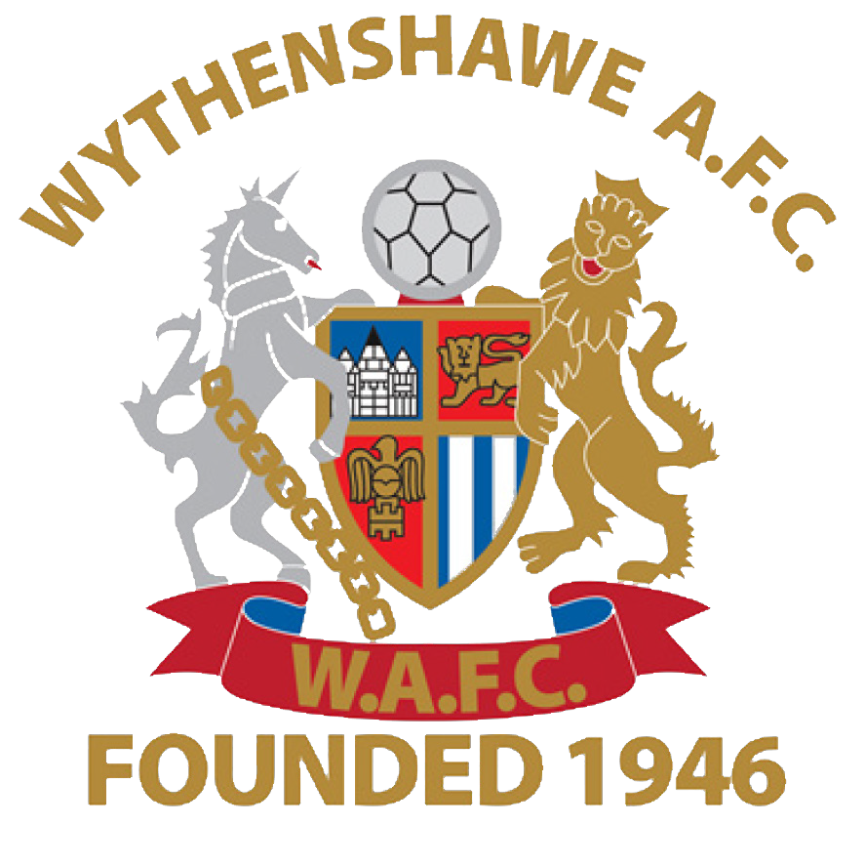

• Although of excellent quality and designed to last, bricks may become worn or damaged over time owing to natural causes. No liability can be accepted for this by Wythenshawe A.F.C.

• Bricks are manufactured to British Standards specifications for size, dimensions, strength, shape, porosity, etc. Colour and texture can vary slightly due to batch processing techniques but such variances are subject to compliance with industrial tolerances.

• Wythenshawe A.F.C. will have complete control over the location and installation date of the bricks.